10.63: The net torque on the pulley is TR, where T is the tension in the string, and 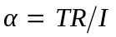. The net force on the block down the ramp is 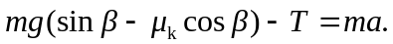
The acceleration of the block and the angular acceleration of the pulley are related by 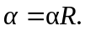

a) Multiplying the first of these relations by 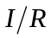 and eliminating in terms of a, and then adding to the second to eliminate T gives

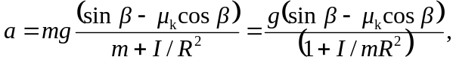

and substitution of numerical values given 1.12 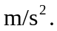 b) Substitution of this result into either of the above expressions involving the tension gives T = 14.0 N.

